# ***INTRO:-***

*C is one of the most widely used programming languages of all time. C is a general-purpose programming language initially developed by Dennis Ritchie between 1969 and 1973 at AT&T Bell Labs.* *Its design provides constructs that map efficiently to typical machine instructions, and therefore it has found lasting use in applications that had formerly been coded in assembly language.*

*Learning about programming was my childhood dream and C has helped me to fulfill it. At present I don’t have the complete power of C in my hand (such as interacting with hardware, GUI, mouse programming, etc…). But I think my existing knowledge about C is (at least) enough to make very simple ‘CLI Game Based Programs’.*

*I chose to program a game since I not only like to play PC games but also curious to know how the games actually are (in the background i.e. source code, their core processes; not their graphics and visuals). In this project I along with my partner have developed 2 simple and 2 (a bit) complex (console based) games which are combined in a simple menu driven program. I have not used any complex graphics but simple keyboard characters are used to give that experience.*

*I have developed the source code in DEV C/C++ compiler on Win 8.1 platform (compatibility issues may arise on other systems).*

*I hope everyone will like the program.*

*Thanking you.*

* *Shriraj*

# ***Problem Statements:-***

*Combine the following programs into a menu driven program:-*

1. *Write a complete c-program to accept any day month and year from the user and determine the day of the equivalent.*
2. *Write a complete c-program to guess any no. from the user (0-9) using simple tree-diagram logic.*
3. *Write a complete c-program for the game of matchstick.*
4. *Write a complete c-program for a game of tile sliding puzzle.*

# Note:

1. *The above problem statements are my own (although I have referred to some books).*
2. *I have used the concept of functions in my programs to prevent compressing everything into ‘main’ and to reuse some of the needful code easily.*
3. *I have used some of my own created functions (for e.g. ipas(); and cpas();) whose necessity will be clearly seen in the source code.*

# ***Algorithm:-***

1. Start
2. Display logo
3. Display menu of the game
4. Display logo of “blox" (1st game)
5. Display logo of “what’s the day” (2nd game)
6. Display logo of “guess my number” (3rd game)
7. Display logo of “lets matchstick” (4th game)
8. Accept User’s choice
9. If( choice==1) //Open Blox
   1. Display “instructions” & menu
   2. Accept the choice of the user
   3. If(c==1)
      1. Accept difficulty level
      2. If (1)
         1. (Beginners/novice)
         2. Display Board (3x3) , no. of steps and status
         3. Accept User’s move using arrow keys (for moving ‘0’ tile)
         4. If up arrow key is pressed then ‘0’ will move up and the replaced tile will come in zero’s place.
         5. If ‘0’ is already in topmost row then no action is taken (for up arrow key)
         6. (Then similar logic for remaining arrow keys)
         7. If all the tiles are in order i.e. in their place
            1. Congratulate the winner
            2. Accept his name and print it in the hall of fame file.
      3. If (2)
         1. (Impresso (more difficult))
         2. (Same logic but bigger board)
   4. If (c==2)
      1. Display the hall of fame
   5. If (c==3)
      1. Exit
10. If (choice==2) //What’s the day
    1. Accept date in dd/mm/yyyy form
    2. Separate century from year using mod.
    3. Determine date, month, year and century remainder and calculate the Grand remainder
    4. Depending on Grand Remainder (0, 1, 2, 3, 4, 5, 6 or 7) determine what the day is.
    5. (All the calculations are done using their respective formulas)
    6. (Please refer to the source code for the same)
11. If (choice==3) //Guess My Number
    1. Display instructions and initial message
    2. using if else statements ask the user if the selected number is present in the group or not
    3. Accept user’s selected choice (y/n)
    4. Using flowchart logic determine user’s chosen number (see flowchart below)

(Note:- Flowchart is just drawn for understanding, it may not have followed actual drawing rules)

(Y=No. in person’s mind is present in the group, N= No. in person’s mind is absent in the group)

N N

4,7,0,2,5

9,6,5,8,1

N Y Y

Y Y N N

2,3,5,9,0

2,4,6,8,0

8,5,3,6,1

Y Y

N N N N

9,3,8,6,2

9,5,0,3,1

4,9,6,7,1

Y Y Y

N

1,3,4,9,0

Y

1. If (choice==4) // Match stick game
   1. Display the initial message on the screen
   2. Display the instructions and the menu
   3. If(c==1)
      1. Accept difficulty level
      2. If (1)
         1. (Mindless)
         2. Display the match sticks
         3. Accept user’s choice
         4. After user’s role computer will determine his choice
         5. If the user picks the last match stick then he/she loses
         6. If the no. of sticks remaining is less than 1 than it’s a tie
         7. If the player wins
            1. Congratulate the winner
            2. Accept his name and print it in the hall of fame file.

* + 1. If (2)
       1. (Intelli)
       2. (Same logic as mindless, but in this level probability of winning is ‘0’)
  1. If (c==2)
     1. Display the hall of fame
  2. If (c==3)
     1. Exit

1. If (choice==esc key)
   1. Display “thank you for playing”
   2. Exit.

# ***Program (source code):-***

*#include <stdio.h>//for std input output*

*#include <stdlib.h>//for exit()*

*#include <conio.h>//for getch()*

*#define CLR (system("cls"))//for clearing screen*

*//BLOX external variables!*

*int diff ,stat=1, st, *zer, cheat=0, cheat2=0; //diff=difficulty, stat=counter for status, st=no.of steps, zer=a pointer variable for storing the address of zero, variable for cheat code.*

*int e[3][3]={*

*{5,6,3},*

*{1,4,8},*

*{7,2,0},*

*};*

*int m[4][5]={*

*{8,16,6,12,5},*

*{11,19,3,17,18},*

*{1,10,14,7,15},*

*{13,4,9,2,0},*

*};*

*//Matchstick external variables!*

*int sticks=21,plr=0,cpu=0,dif;//sticks=no. of matchsticks, plr=player's choice, cpu=cpu's choice, dif=difficulty*

*//Real Program begins......*

*int main()*

*{*

*int key;*

*printf(“SR”); //LOGO (for actual logo refer to original program)*

*getch();*

*reset:*

*CLR;*

*printf(“4 Fun”); (for actual menu refer to original program)*

*printf("\n\n\n\n");*

*printf("\n\t\t\t ------------------------");*

*printf("\n\t\t\t | |");*

*printf("\n\t\t\t | %c BLOX! %c |",254,254);*

*printf("\n\t\t\t | |");*

*printf("\n\t\t\t ------------------------\n\n\n");*

*printf("\n\t\t\t ------------------------");*

*printf("\n\t\t\t | |");*

*printf("\n\t\t\t | %c WHAT's THE DAY? %c |",15,15);*

*printf("\n\t\t\t | |");*

*printf("\n\t\t\t ------------------------\n\n\n");*

*printf("\n\t\t\t ------------------------");*

*printf("\n\t\t\t | |");*

*printf("\n\t\t\t | %c GUESS MY NUMBER! %c |",2,2);*

*printf("\n\t\t\t | |");*

*printf("\n\t\t\t ------------------------\n\n\n");*

*printf("\n\t\t\t ------------------------");*

*printf("\n\t\t\t | |");*

*printf("\n\t\t\t |%c LET's MATCHSTICK!! %c|",4,4);*

*printf("\n\t\t\t | |");*

*printf("\n\t\t\t ------------------------\n\n\n");*

*printf("\n\t\t\t ENTER 'ESC' KEY TO QUIT!");*

*printf("\n\n\n\t\t Please Enter Your Choice (1,2,3,4): ");*

*key=getkey();*

*switch(key) {*

*//blox*

*case 49:{*

*int fl=2, c;//hall of fame file variable & menu choice variable*

*char r;// yes or no variable*

*do { //The game loop*

*st=0;//no. of steps*

*loading();*

*CLR;*

*printf("\n *********##^^^^^^^^ Welcome to the Mindtwister Game : BLOX ^^^^^^^^##*********\n");*

*getch();*

*printf("\n\n=>Instruction:");*

*printf("\n\nIn this game, a frame of square pieces will be shown on the screen.\nThe pieces can be moved horizontally and vertically with the help of arrow keys.\nA possible arrangement of pieces is (for example):-\n\n");getch();*

*printf("\n Before Solving After Solving\n\n");*

*printf("\n _______________________ _______________________");*

*printf("\n | | | | | | | | | |");*

*printf("\n | 10 | 7 | 5 | 1 | | 1 | 2 | 3 | 4 |");*

*printf("\n | | | | | | | | | |");*

*printf("\n _______________________ _______________________");*

*printf("\n | | | | | | | | | |");*

*printf("\n | 4 | 8 | 3 | 11 | | 5 | 6 | 7 | 8 |");*

*printf("\n | | | | | | | | | |");*

*printf("\n _______________________ _______________________");*

*printf("\n | | | | | | | | | |");*

*printf("\n | 2 | 6 | 9 | 0 | | 9 | 10 | 11 | 0 |");*

*printf("\n | | | | | | | | | |");*

*printf("\n _______________________ _______________________");*

*printf("\n\n\nAs you can see there is a '0' at the bottom right corner.\nWith the help of arrow keys you can replace the '0' with the piece(s)\nnearest to it.\n\n\nYour goal is :\nTO ARRANGE THE PIECES IN THE ASCENDING ORDER OF THE NUMBERS WITH MINIMUM STEPS.\nLess the steps higher the ranking will be.\n");*

*getch();*

*printf("\nSo what are we waiting for! Lets BEGINNNNNN........!!!!!\n");*

*getch();*

*reset3:*

*CLR;*

*c=ipas("\n <==### MAIN MENU ###==>\n\t _________\n\n\t1) New Game\n\n\t2) Hall of Fame\n\n\t3) Exit\n\nYour Choice: ");*

*switch(c) {*

*case 1: reset2:*

*CLR;*

*diff=ipas("\nChoose your difficulty level:-\n\n1)Novice\n\n2)Impresso\n\n3)Hell Fire\n\nYour Choice: ");*

*switch(diff) {*

*case 1:zer=&e[2][2];*

*novice(fl);//difficulty selections; the functions are defined at the end seperately*

*break;*

*case 2:zer=&m[3][4];*

*impresso(fl);//fl is used to handle opening and editing of different files for different games*

*break;*

*case 3:hell(fl);//this level is under development.(as this is my first finished version)*

*goto reset2;*

*break;*

*default:printf("\nINVALID CHOICE!!");getch(); goto reset2;//reset is used (often in this program) to continue from the section where an invalid input was given.*

*}*

*break;*

*case 2:fileop(fl);//to open the file of game winners.*

*goto reset3;*

*break;*

*case 3:goto reset;*

*default:printf("\nINVALID CHOICE!!");getch(); goto reset3;*

*}*

*r=cpas("\n\n\nGAME OVER!\n\nDo You want to play again? (y/n)\n\nYour Choice: ");*

*}*

*while(r=='y');*

*}*

*goto reset;*

*//what's the day*

*case 50:{*

*int d,m,y,c,n,dr,mr,yr,R,a,cd,x;//d=day,m=month,y=year,c=century,n=;dr=day remainder,similarly mr & yr,R=total Remainder;*

*char cho;*

*do {*

*CLR;*

*printf("\t ###########--> Welcome to What's the Day!? <--############");*

*printf("\n\n\n Enter the date in dd/mm/yyyy format: ");*

*scanf("%d/%d/%d",&d,&m,&y); //this game is completely formula based. Actually this game is transformed into C program from the mathematical book.*

*x=y;*

*c=y/100;*

*y=y%100;*

*dr=d%7;*

*mr=(m==1?1:(m==2?4:(m==3?4:(m==4?0:(m==5?2:(m==6?5:(m==7?0:(m==8?3:(m==9?6:(m==10?1:(m==11?4:(m==12?6:m))))))))))));*

*yr=(y+(y/4))%7;*

*a=19;*

*cd=-1;*

*n=(a)+(c*cd);*

*R=dr+mr+yr+n;*

*if(R<0) {*

*R%=7;*

*R+=7;*

*}*

*else if(R>0) {*

*R%=7;*

*}*

*if(R==0||R==7) {*

*printf("\n\n The day on %d/%d/%d is Saturday\a.",d,m,x);*

*}*

*else if(R==1) {*

*printf("\n\n The day on %d/%d/%d is Sunday\a.",d,m,x);*

*}*

*else if(R==2) {*

*printf("\n\n The day on %d/%d/%d is Monday\a.",d,m,x);*

*}*

*else if(R==3) {*

*printf("\n\n The day on %d/%d/%d is Tuesday\a.",d,m,x);*

*}*

*else if(R==4) {*

*printf("\n The day on %d/%d/%d is Wednesday\a.",d,m,x);*

*}*

*else if(R==5) {*

*printf("\n\n The day on %d/%d/%d is Thursday\a.",d,m,x);*

*}*

*else if(R==6) {*

*printf("\n\n The day on %d/%d/%d is Friday\a.",d,m,x);*

*}*

*printf("\n\n Game Over!\n\n Do you want to play Again? (y/n)\n Reply: ");*

*scanf(" %c",&cho);*

*}*

*while (cho=='y');*

*}*

*goto reset;*

*//guess my no.*

*case 51:{*

*char cho;*

*do { //This game is based on simple logic.(easily understood from the flow chart)*

*CLR;*

*int result;*

*printf("Note:-{press enter on your keyboard for next instruction or just do\nwhat the computer says}\n");*

*printf("\nHello,I am Your friend, your PC!.\n");*

*getch();*

*printf("\nNow I am going to show you a magic trick.\n");*

*getch();*

*printf("\nIn the following exercise enter 'y' for yes and 'n' for no.\n");*

*getch();*

*printf("\nAssume any single digit number in your mind.\nDon't reveal it to me.\n");*

*getch();*

*CLR;*

*printf("\nIs the number assumed by you present in this set?\n{4,7,0,2,5}\n(press 'y' or 'n')\n");*

*result=getkey();*

*CLR;*

*if (result==110) {*

*printf("\nIs the number assumed by you present in this set?\n{9,6,5,1,8}\n(press 'y' or 'n')\n");*

*result=getkey();*

*CLR;*

*if (result==110) {*

*printf("\nThe number assumed by you is '3'");*

*}*

*else if (result==121) {*

*printf("\nIs the number assumed by you present in this set?\n{8,5,3,6,1}\n(press 'y' or 'n')\n");*

*result=getkey();*

*CLR;*

*if (result==110) {*

*printf("\nThe number assumed by you is '9'");*

*}*

*else if (result==121) {*

*printf("\nIs the number assumed by you present in this set?\n{4,9,1,7,6}\n(press 'y' or 'n')\n");*

*result=getkey();*

*CLR;*

*if (result==110) {*

*printf("\nThe number assumed by you is '8'");*

*}*

*else if (result==121) {*

*printf("\nIs the number assumed by you present in this set?\n{1,3,4,9,0}\n(press 'y' or 'n')\n");*

*result=getkey();*

*CLR;*

*if (result==110) {*

*printf("\nThe number assumed by you is '6'");*

*}*

*else if (result==121) {*

*printf("\nThe number assumed by you is '1'");*

*}*

*}*

*}*

*}*

*}*

*else if (result==121) {*

*printf("\nIs the number assumed by you present in this set?\n{2,4,6,8,0}\n(press 'y' or 'n')\n");*

*result=getkey();*

*CLR;*

*if (result==110) {*

*printf("\nIs the number assumed by you present in this set?\n{5,3,2,9,0}\n(press 'y' or 'n')\n");*

*result=getkey();*

*CLR;*

*if (result==110) {*

*printf("\nThe number assumed by you is '7'");*

*}*

*else if (result==121) {*

*printf("\nThe number assumed by you is '5'");*

*}*

*}*

*else if (result==121) {*

*printf("\nIs the number assumed by you present in this set?\n{9,5,0,3,1}\n(press 'y' or 'n')\n");*

*result=getkey();*

*CLR;*

*if (result==110) {*

*printf("\nIs the number assumed by you present in this set?\n{9,3,8,6,2}\n(press 'y' or 'n')\n");*

*result=getkey();*

*CLR;*

*if (result==110) {*

*printf("\nThe number assumed by you is '4'");*

*}*

*else if (result==121) {*

*printf("\nThe number assumed by you is '2'");*

*}*

*}*

*else if (result==121) {*

*printf("\nThe number assumed by you is '0'");*

*}*

*}*

*}*

*printf("\n\n Game Over!\n\n Do you want to play Again? (y/n)\n Reply: ");*

*scanf(" %c",&cho);*

*}*

*while (cho=='y');*

*}*

*goto reset;*

*//let's matchstick*

*case 52:{*

*int fl=1, c;//hall of fame file variable & menu choice variable*

*char r;//yes or no variable*

*do {*

*int n=sticks;*

*loading();*

*CLR;*

*printf("\n ********* Welcome to the ultimate man-machine showdown: MATCHSTICKS **********\n -->>where human brain is pit against silicon processor!\n\n");*

*getch();*

*printf("\n\n=>Instruction:");*

*printf("\nIn this game, each one will have to pick up the matchsticks(1,2,3 or 4)\naccording to their turn.");*

*printf("\nThe one to pick up the last stick will be the loser!");*

*getch();*

*printf("\n\nPC:'So, are you fit enough to chalenge me!'");*

*getch();*

*reset5:*

*CLR;*

*printf("\n <==### MAIN MENU ###==>\n\t _________\n\n\t1) New Game\n\n\t2) Hall of Fame\n\n\t3) Exit\n\nYour Choice: ");*

*scanf(" %d",&c);*

*switch(c) {*

*case 1: reset6:*

*CLR;*

*printf("\nChoose your difficulty level:-\n\n1)Mindless mode\n2)Intelli mode\n\nYour Choice: ");*

*scanf(" %d",&dif);*

*switch(dif) {*

*case 1:mindless(n,fl);// difficulty selection (each function is defined at the end seperately)*

*break;*

*case 2:intelli(n,fl);*

*break;*

*default:printf("\nINVALID CHOICE!!"); goto reset6;*

*}*

*break;*

*case 2:fileop(fl);//to open the file of game winners.*

*goto reset5;*

*break;*

*case 3:goto reset;*

*default:printf("\nINVALID CHOICE!!"); goto reset5;*

*}*

*CLR;*

*printf("\n\n\nGAME OVER!\n\nDo You want to play again? (y/n)\n\nYour Choice: ");*

*scanf(" %c",&r);*

*}*

*while(r=='y');*

*}*

*goto reset;*

*case 27:CLR; printf(“Thank you for playing”);*

*getch();*

*exit(0);*

*default:printf("\nINVALID CHOICE!!");getch(); goto reset;*

*}*

*return 0;*

*}//THE END of main......*

*//Blox functions!*

*void dispboard()//function used to display the blox grid along with its numbers.*

*{*

*CLR;*

*switch(diff) {*

*case 1: printf("\n\t\tBLOX!\t\t\tDifficulty: Novice\n\n\n");*

*printf("\n _________________");*

*printf("\n | | | |");*

*printf("\n | %d | %d | %d |",(e[0][0]),(e[0][1]),(e[0][2]));*

*printf("\n | | | |");*

*printf("\n _________________");*

*printf("\n | | | |");*

*printf("\n | %d | %d | %d |",(e[1][0]),(e[1][1]),(e[1][2]));*

*printf("\n | | | |");*

*printf("\n _________________");*

*printf("\n | | | |");*

*printf("\n | %d | %d | %d |",(e[2][0]),(e[2][1]),(e[2][2]));*

*printf("\n | | | |");*

*printf("\n _________________\n\n");*

*status();*

*break;*

*case 2: printf("\n\t\tBLOX!\t\t\t\tDifficulty: Impresso\n\n\n");*

*printf("\n _____________________________");*

*printf("\n | | | | | |");*

*printf("\n | %2d | %2d | %2d | %2d | %2d |",(m[0][0]),(m[0][1]),(m[0][2]),(m[0][3]),(m[0][4]));*

*printf("\n | | | | | |");*

*printf("\n _____________________________");*

*printf("\n | | | | | |");*

*printf("\n | %2d | %2d | %2d | %2d | %2d |",(m[1][0]),(m[1][1]),(m[1][2]),(m[1][3]),(m[1][4]));*

*printf("\n | | | | | |");*

*printf("\n _____________________________");*

*printf("\n | | | | | |");*

*printf("\n | %2d | %2d | %2d | %2d | %2d |",(m[2][0]),(m[2][1]),(m[2][2]),(m[2][3]),(m[2][4]));*

*printf("\n | | | | | |");*

*printf("\n _____________________________");*

*printf("\n | | | | | |");*

*printf("\n | %2d | %2d | %2d | %2d | %2d |",(m[3][0]),(m[3][1]),(m[3][2]),(m[3][3]),(m[3][4]));*

*printf("\n | | | | | |");*

*printf("\n _____________________________");*

*status();*

*break;*

*case 3: //Under development!*

*break;*

*}*

*}*

*//actually blox is mainly a passing the parcel between player and dispboard functions!*

*player()*

*{ //this is actually the heart of the blox game. Here every move is processed and then sent to dispboard for printing.*

*int x; //the globally declared array (at the top) is used here. They are globaly declared to avoid the mess of passing them.*

*reset4:*

*x=getkey();*

*switch(x) { //up arrow result*

*case 328:if(diff==1) { //for difficulty level 1*

*if((e[0][0]==0)||(e[0][1]==0)||(e[0][2]==0)) goto reset4;//this means don't respond if 0 is already at the topmost row and similar logic for the remaining.*

*swap(zer,(zer-3));*

*zer-=3;*

*}*

*else { //for difficulty level 2*

*if((m[0][0]==0)||(m[0][1]==0)||(m[0][2]==0)||(m[0][3]==0)||(m[0][4]==0)) goto reset4;*

*swap(zer,(zer-5));*

*zer-=5;*

*}*

*break;*

*case 336:if(diff==1) { //similarly down*

*if((e[2][0]==0)||(e[2][1]==0)||(e[2][2]==0)) goto reset4;*

*swap(zer,(zer+3));*

*zer+=3;*

*}*

*else {*

*if((m[3][0]==0)||(m[3][1]==0)||(m[3][2]==0)||(m[3][3]==0)||(m[3][4]==0)) goto reset4;*

*swap(zer,(zer+5));*

*zer+=5;*

*}*

*break;*

*case 331:if(diff==1) {// left*

*if((e[0][0]==0)||(e[1][0]==0)||(e[2][0]==0)) goto reset4;*

*swap(zer,(zer-1));*

*zer-=1;*

*}*

*else {*

*if((m[0][0]==0)||(m[1][0]==0)||(m[2][0]==0)||(m[3][0]==0)) goto reset4;*

*swap(zer,(zer-1));*

*zer-=1;*

*}*

*break;*

*case 333:if(diff==1) { // right*

*if((e[0][2]==0)||(e[1][2]==0)||(e[2][2]==0)) goto reset4;*

*swap(zer,(zer+1));*

*zer+=1;*

*}*

*else {*

*if((m[0][4]==0)||(m[1][4]==0)||(m[2][4]==0)||(m[3][4]==0)) goto reset4;*

*swap(zer,(zer+1));*

*zer+=1;*

*}*

*break;*

*case 115:cheat=1;//115=s, a small cheating in the game....*

*break;*

*case 27: exit(0);*

*default:printf("\nINVALID CHOICE!!");getch(); goto reset4;*

*}*

*st++;// steps counter*

*}*

*status()// this will automatically update the status displayed ( for e.g no. of steps, etc) it interacts with dispboard.*

*{*

*int x2;*

*printf("\n\n\n\nSTATUS:\n\nNo. of Steps: %d",st);*

*stat++;*

*if(stat==4) printf("\n\n\nAgent SR: Common! You can do it!!");*

*if(stat==8) printf("\n\n\nAgent SR: Don't give up!");*

*if(stat==12)printf("\n\n\nAgent SR: Keep on trying!!");*

*if(stat==16) {*

*printf("\n\n\nAgent SR: Try and Try till SUCCESS!!!");// just for encouragement...*

*stat=1;*

*}*

*if(cheat) {*

*printf("\n\nCHEAT MODE:\n\n1) Reset the no. of steps (please press any arrow key after using this cheat to see its effect!)\n\n2) Finish the Game\n");*

*reset5:*

*x2=getkey();*

*switch(x2) {*

*case 49:st=-1;*

*cheat=0;*

*break;*

*case 50:cheat2=1;*

*break;*

*default:printf("\nINVALID CHOICE!!"); goto reset5;*

*}*

*}*

*}*

*novice(int fl)*

*{*

*do {*

*dispboard();*

*if(cheat2) break;*

*player();*

*}*

*while((e[0][0]!=1)||(e[0][1]!=2)||(e[0][2]!=3)||(e[1][0]!=4)||(e[1][1]!=5)||(e[1][2]!=6)||(e[2][0]!=7)||(e[2][1]!=8)||(e[2][2]!=0));//cross check if the player has won the game or not and similar for below.*

*CLR;*

*printf("\n\nCONGRATULATIONS\n\n\nYou won the game in %d steps!!!",st);*

*file(fl);//opens file to enter data like name and store in it*

*getch();*

*}*

*impresso(int fl)//same as above*

*{*

*do {*

*dispboard();*

*if(cheat2) break;*

*player();*

*}*

*while((m[0][0]!=1)||(m[0][1]!=2)||(m[0][2]!=3)||(m[0][3]!=4)||(m[0][4]!=5)||(m[1][0]!=6)||(m[1][1]!=7)||(m[1][2]!=8)||(m[1][3]!=9)||(m[1][4]!=10)||(m[2][0]!=11)||(m[2][1]!=12)||m[2][2]!=13||(m[2][3]!=14)||(m[2][4]!=15)||(m[3][0]!=16)||(m[3][1]!=17)||(m[3][2]!=18)||(m[3][3]!=19)||(m[3][4]!=0));*

*CLR;*

*printf("\n\nCONGRATULATIONS\n\n\nYou won the game in %d steps!!!",st);*

*file(fl);*

*getch();*

*}*

*hell(int fl)*

*{*

*printf("\n\n'System Malfunction'==>\n This level is under development!\nPlease choose another level!\n\nThank you for your co-operation....");getch();//sorry sir, but i am planning some awesome tricks to include in this level. It will take time.*

*} //I want to skip this until examinations..*

*//Matchstick functions!*

*mindless(int n,int fl)*

*{*

*int t=0;*

*do {*

*CLR;*

*int i,j=1,k=0,l=0,m=0;*

*printf("\nMATCHSTICKS=>\n\n\n\n"); //loop used to display the matchsticks*

*for(i=1;i<=n;i++) { //logic used is*

*if(j)printf(" @"); //first only display the head part and reset the main loop*

*if(k)printf(" |"); //then instead start the inner secind loop and display second part and then reset*

*if(l)printf(" |"); //similarly this*

*if(m)printf(" |"); //and this then end the main loop*

*if(i==n && j==1) {*

*j=0;*

*k=1;*

*i=0;*

*printf("\n");*

*}*

*if(i==n && k==1) {*

*k=0;*

*l=1;*

*i=0;*

*printf("\n");*

*}*

*if(i==n && l==1) {*

*l=0;*

*m=1;*

*i=0;*

*printf("\n");*

*}*

*}*

*if(n==sticks) printf("\n\n\nPC:'Let us see, who wins this challenge!'");//PC dialogues just for entertain ment*

*if(t) {*

*if(n==1) { //checkout block if the player has won or not*

*printf("\n\nYou Won The Game!\n\n''CONGRATULATIONS!!''\n");*

*file(fl);//opens file to enter data like name and store in it*

*printf("\n\nPC:'Don't celeberate human! Try harder level if you dare!!'");*

*getch();*

*break;*

*}*

*cpu=cpum(n);//cpu logic to return a counter value against player*

*if(n<=cpu) { CLR;printf("\n\nThe Game is declared as a TIE between player & PC.\n\nPC: #!?\n");getch();break;} //to check if there is a tie*

*n-=cpu;*

*getch();*

*t=0;//a variable for alternating the round between pc and plr*

*continue;*

*}*

*if(!t) {*

*if(n==1) { //checkout block if the pc has won or not*

*printf("\n\nYou Lose The Game!\n\nBetter luck next time!");*

*printf("\n\nPC:'Ha!Ha!!Haaa.....!'\n 'I had told you human, you are ''LOSER!!''");*

*getch();*

*break;*

*}*

*t=1;*

*plr=plrf(n);*

*if(n<=plr) { CLR;printf("\n\nThe Game is declared as a TIE between player & PC.\n\nPC: #!?\n");getch();break;} //to check if there is a tie*

*n-=plr;*

*}*

*}*

*while(n);*

*}*

*intelli(int n,int fl) // same logic as above with minor changes*

*{*

*int t=0;*

*do {*

*CLR;*

*int i,j=1,k=0,l=0,m=0;*

*printf("\nMATCHSTICKS=>\n\n\n\n");*

*for(i=1;i<=n;i++) {*

*if(j)printf(" @");*

*if(k)printf(" |");*

*if(l)printf(" |");*

*if(m)printf(" |");*

*if(i==n && j==1) {*

*j=0;*

*k=1;*

*i=0;*

*printf("\n");*

*}*

*if(i==n && k==1) {*

*k=0;*

*l=1;*

*i=0;*

*printf("\n");*

*}*

*if(i==n && l==1) {*

*l=0;*

*m=1;*

*i=0;*

*printf("\n");*

*}*

*}*

*if(n==sticks) printf("\n\nPC:'Now you will see the true power of silicon chip!'");*

*if(t) {*

*if(n==1) {*

*printf("\n\nYou Won The Game!\n\n''CONGRATULATIONS!!''\n");*

*file(fl);*

*printf("\n\nPC:'Don't think that this is over human!'\n 'I'll be watching you!'\n");*

*getch();*

*break;*

*}*

*cpu=cpuf(n);//cpu logic to return a counter value against player*

*n-=cpu;*

*getch();*

*t=0;*

*continue;*

*}*

*if(!t) {*

*if(n==1) {*

*printf("\n\nYou Lose The Game!\nBetter luck next time!\n");*

*printf("\n\nPC:'Ha!Ha!!Haaa.....!'\n 'I had told you human, you are ''LOSER!!''");*

*getch();*

*break;*

*}*

*plr=plrf(n);*

*n-=plr;*

*t=1;*

*}*

*}*

*while(n);*

*}*

*int plrf(int n) //used to input value from the user*

*{*

*int x;*

*reset3:*

*printf("\n\nHow many sticks will you pick?(1,2,3 or 4)\n\nYour Choice: ");*

*scanf(" %d",&x);*

*switch(x) {*

*case 1:return (x);*

*case 2:return (x);*

*case 3:return (x);*

*case 4:return (x);*

*case 1997:printf("\n\nCheat Mode:\n\nEnter any no. of sticks you want to pick: ");*

*scanf(" %d",&x); //a small cheat in the game*

*return (x);*

*default:printf("\nINVALID CHOICE!!"); goto reset3;*

*}*

*}*

*int cpuf(int n)// used to determine cpu's choice (this one is litle bit witty)*

*{*

*printf("\n\nPC:It's my turn!\n\n(Thinking....)");*

*int y1;*

*int y[3][4]={*

*{4,9,14,19},*

*{3,8,13,18},*

*{2,7,12,17},*

*};*

*if(n%5==0) {*

*printf("\n\nPC:My choice is 4.\n");*

*return 4;*

*}*

*for(y1=0;y1<=3;y1++) {*

*if(y[0][y1]==n) {printf("\n\nPC:My choice is 3.\n");return 3;}*

*if(y[1][y1]==n) {printf("\n\nPC:My choice is 2.\n");return 2;}*

*if(y[2][y1]==n) {printf("\n\nPC:My choice is 1.\n");return 1;}*

*}*

*}*

*int cpum(int n)//cpu logic (this one is complete mindless)*

*{*

*printf("\n\nPC:It's my turn!\n");*

*int calc;*

*calc=(n*plr)%4+1;*

*printf("\n\nPC:My choice is %d.\n",calc);*

*return (calc);*

*}*

*//Other functions!*

*file(int fl) //for editing*

*{*

*FILE *fptr;*

*char name[20];*

*if(fl==2) {*

*fptr = fopen ("hall of fame2.txt", "a");*

*if (fptr == NULL)*

*{*

*printf("\n\nFile does not exists \n");*

*return;*

*}*

*printf("\nEnter your name: ");*

*scanf("%s",&name);*

*if(0) {*

*fprintf(fptr,"\n\t\t\t******HALL OF FAME******\n\n NAME\t\t\t\tRANKING\t\t\t\tMoves\n ____\t\t\t\t_______\t\t\t\t_____\n\n");*

*}*

*fprintf(fptr, "\n>) %s\t\t\t\t",name);*

*switch(diff) {*

*case 1:fprintf(fptr,"Novice");*

*break;*

*case 2:fprintf(fptr,"Impresso");*

*break;*

*case 3:fprintf(fptr,"Hell Fire");*

*break;*

*}*

*fprintf(fptr, "\t\t\t\t %d",st);*

*}*

*else if(fl==1) {*

*fptr = fopen ("hall of fame1.txt", "a");*

*if (fptr == NULL)*

*{*

*printf("\n\nFile does not exists \n");*

*return;*

*}*

*printf("\nEnter your name: ");*

*scanf("%s",&name);*

*if(0) fprintf(fptr,"\n\t******HALL OF FAME******\n\n NAME\t\t\t\tRANKING\n ____\t\t\t\t_______\n\n");*

*fprintf(fptr, "\n>) %s\t\t\t\t",name);*

*(dif==1)?(fprintf(fptr,"Mindless")):(fprintf(fptr,"Intelli"));*

*}*

*printf("\n\nCheck out the Hall of Fame menu for seeing the people \nwho had won this game.");*

*getch();*

*fclose(fptr);*

*}*

*fileop(int fl) //for opening*

*{*

*FILE *fptr;*

*char ch;*

*CLR;*

*if(fl==2) fptr = fopen ("hall of fame2.txt", "r");*

*else if(fl==1) fptr = fopen ("hall of fame1.txt", "r");*

*if (fptr == NULL)*

*{*

*printf("\n\nCannot open file\n");*

*exit(0);*

*}*

*ch = fgetc(fptr);*

*while (ch != EOF)*

*{*

*printf ("%c", ch);*

*ch = fgetc(fptr);*

*}*

*fclose(fptr);*

*printf("\n\nPress enter to return to main menu");*

*getch();*

*}*

*int getkey()//to get a scancode of the key pressed*

*{*

*int ch = getch();*

*if ( ch == 0 || ch == 224 )*

*ch = 256 + getch();*

*return ch;*

*}*

*swap(int *a,int *b)// to swap the two variables(using call by reference)*

*{*

*int t;*

*t=*a;*

*\*a=*b;*

*\*b=t;*

*}*

*loading()*

*{*

*CLR;*

*printf("\nLoading source code....\nLoading interface....\nLoading game...\n(Press Enter to Continue)");*

*getch();*

*}*

*int ipas(char c[])// print and scan an int*

*{*

*int d;*

*printf("\n%s",c);*

*scanf(" %d",&d);*

*return d;*

*}*

*int cpas(char c[])// print and scan a char*

*{*

*char d;*

*printf("\n%s",c);*

*scanf(" %c",&d);*

*return d;*

*}*

# ***Sample Output:-***

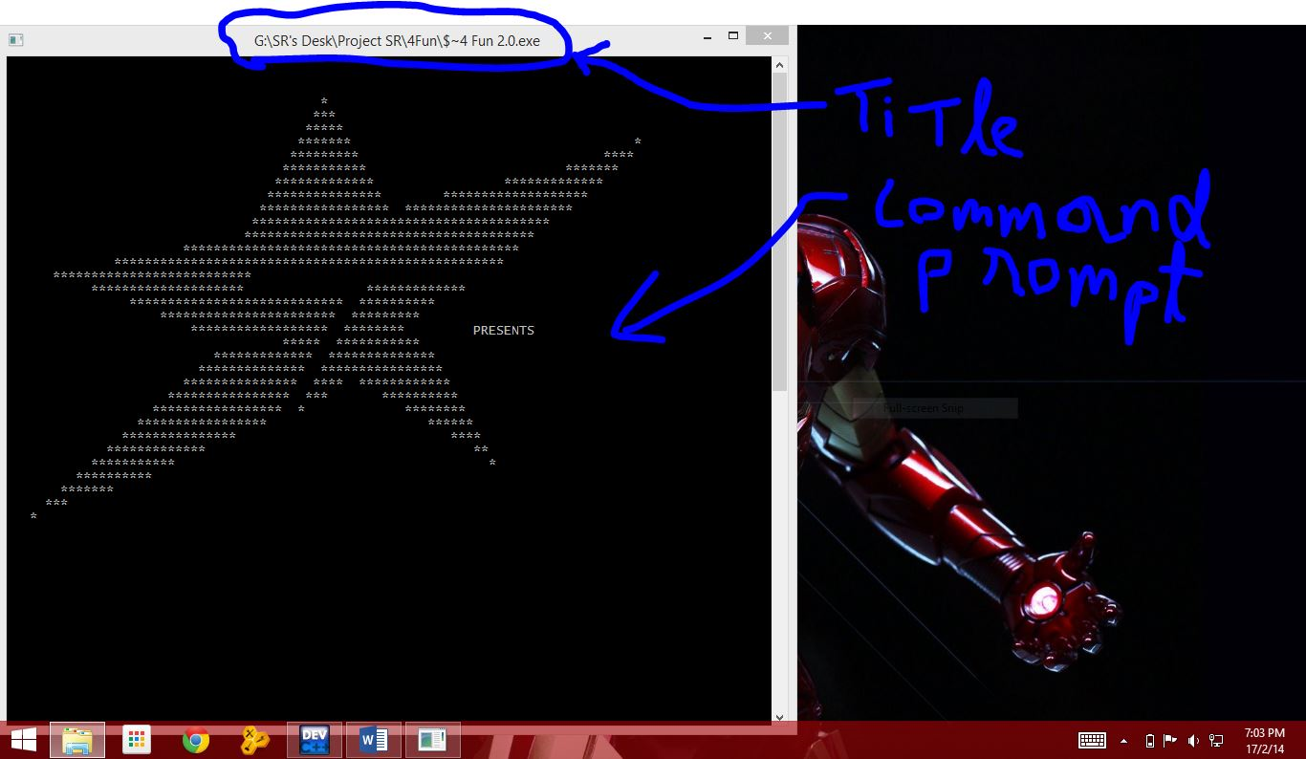

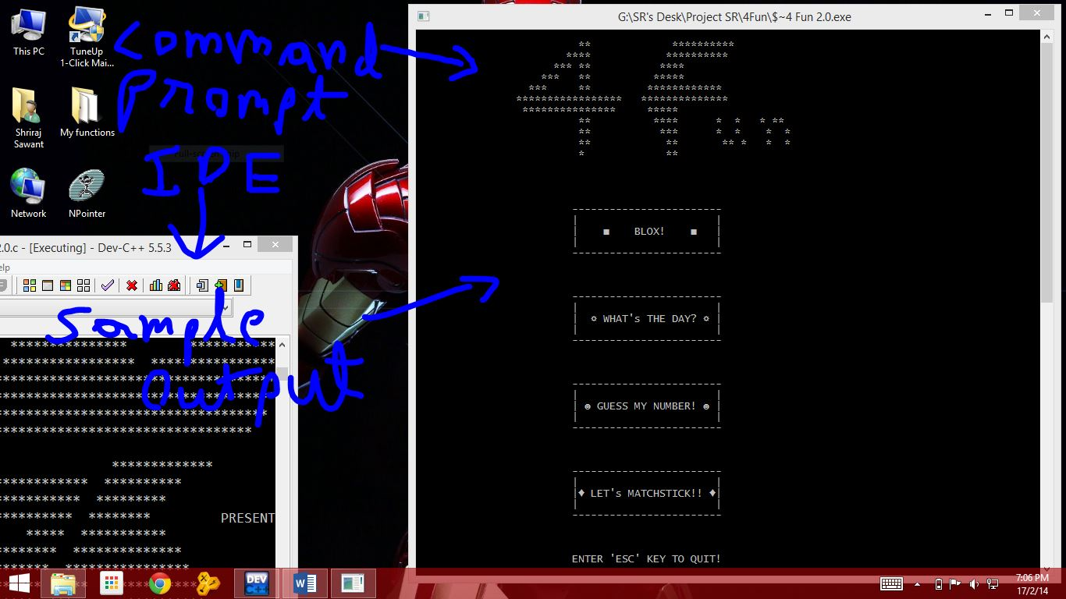

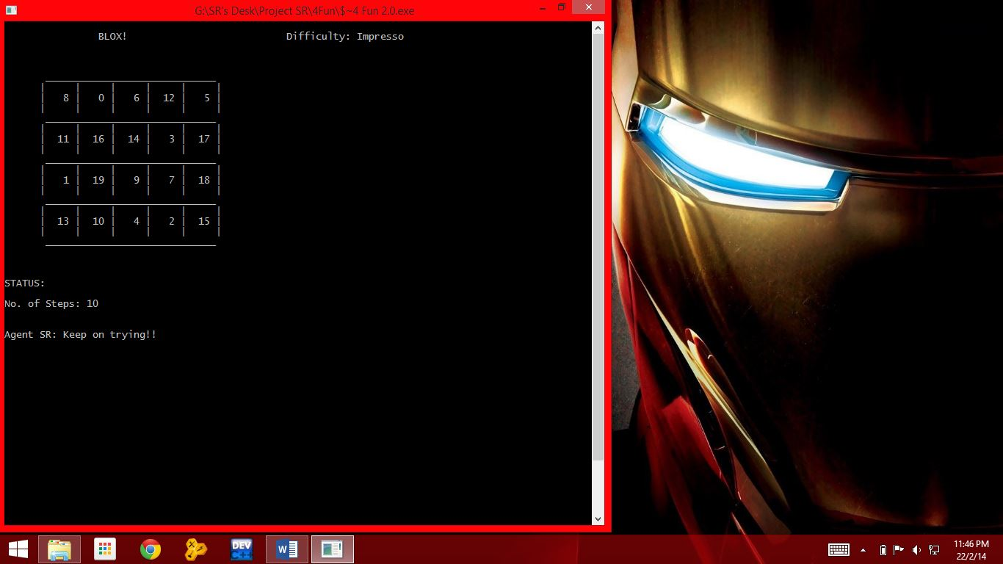

# ***Reference:-***

* *Let us C by Yeshwant Kanetkar*
* *www.Wikipaedia.org.in/ C programming*
* *C/C++ Programming guide (a win 8 app)*
* *Tricks & Traps in C/C++*